How to ‘blog’ Tutorial
Basic Information
- What is a blog? A blog is a log that is put online. They are used for many things including posting your thoughts, giving others useful links, updating news, photos or videos. Since the material is online the possibilities are endless. With that said, everyone can see what you are posting.

- What is the format of a blog? Each section is called a post; A 'post' is just another way of saying an entry, like an entry in a diary, or a column in a newspaper. Posts should have; a header or heading, subject (main part of the post), and a time and date stamp. Once the post has gone up other people are able to leave comments on what you said. Finally, blogs are posted in reverse chronological order, the latest post will be at the top of the page.

- Examples of blogs you might have heard of. Myspace, Facebook, Twitter, Blogger, or Wordpress.
Step-by-step setup guide
- First, you need to open your internet browser.
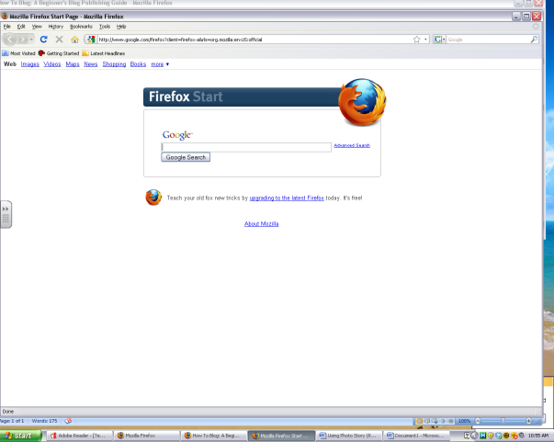

- Type ( http://misskepple.21classes.com/ ) into your address bar at the top of the window.
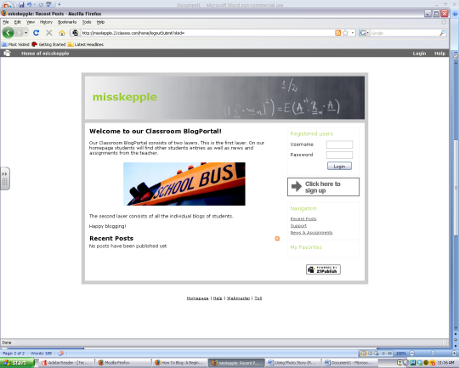

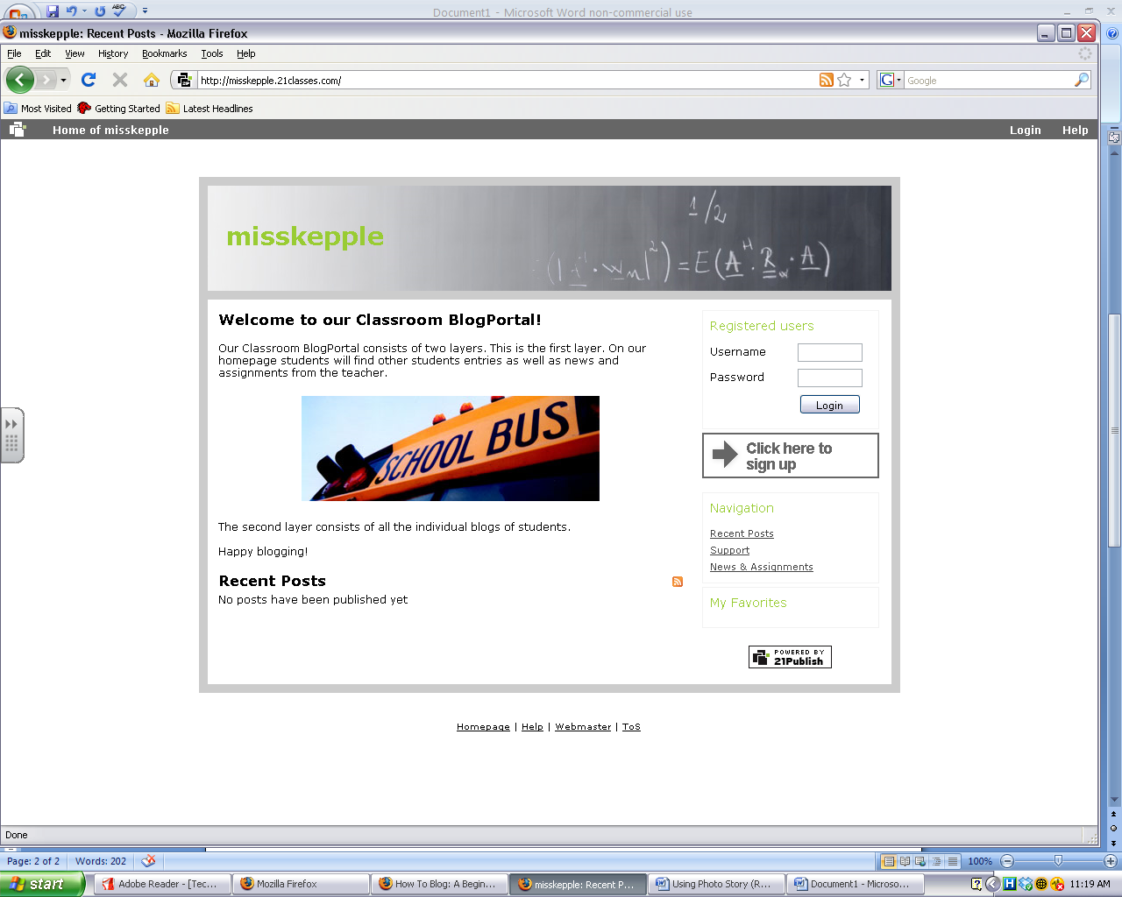
- Our class blog page should come up on the screen.

- Click on ‘Click here to sign up’ to create your own blog page.
- Once opened, you will need to put your information into each box. Remember, you must have an email account to create a blog page. (Some students will be using their parents emails)
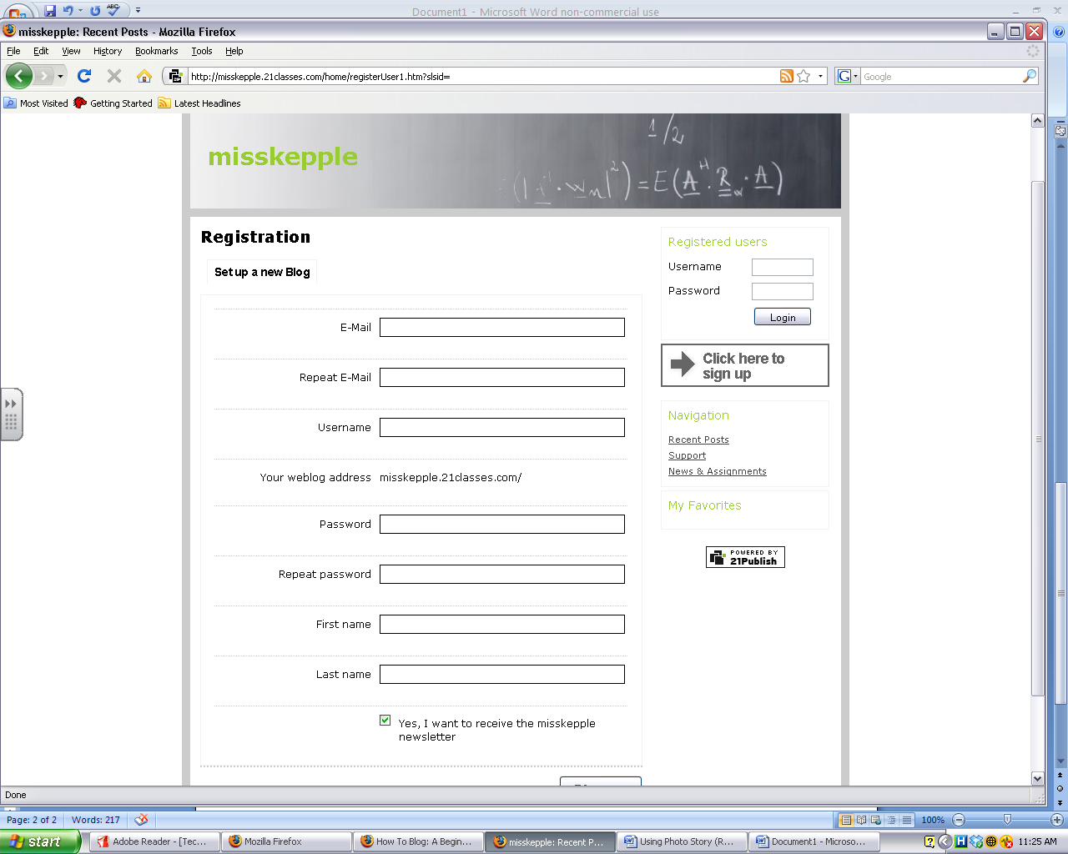
Write your username and password down! Keep it in a safe place.

- This weblog is only for our class so I will need to approve each account. You will get this message until I have approved you.
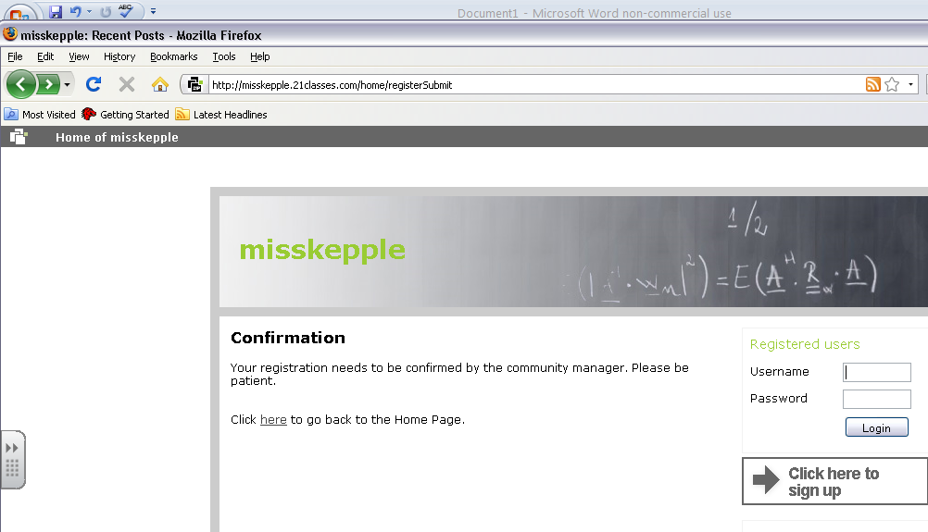

- Once you have been approved you can login to ( http://misskepple.21classes.com/ ). Enter your username and password. Your homepage should look like this.
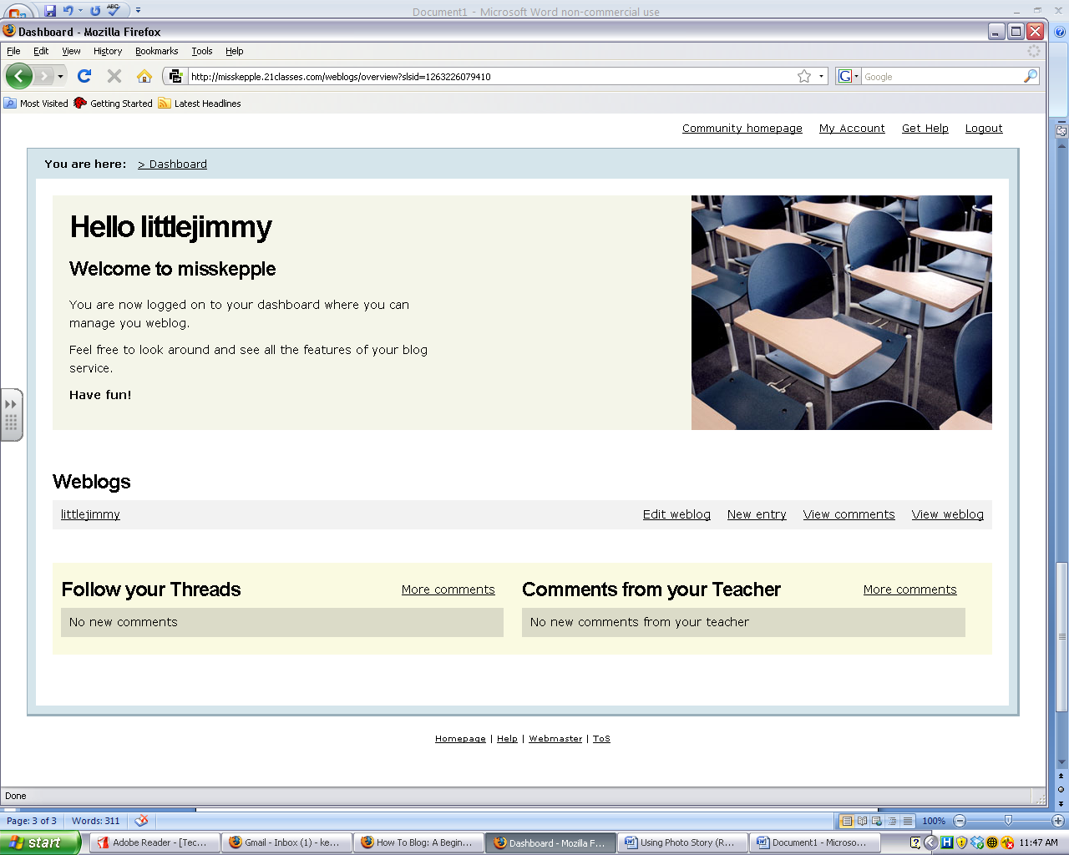
- Now you are going to create your blog. On your home page choose new entry.
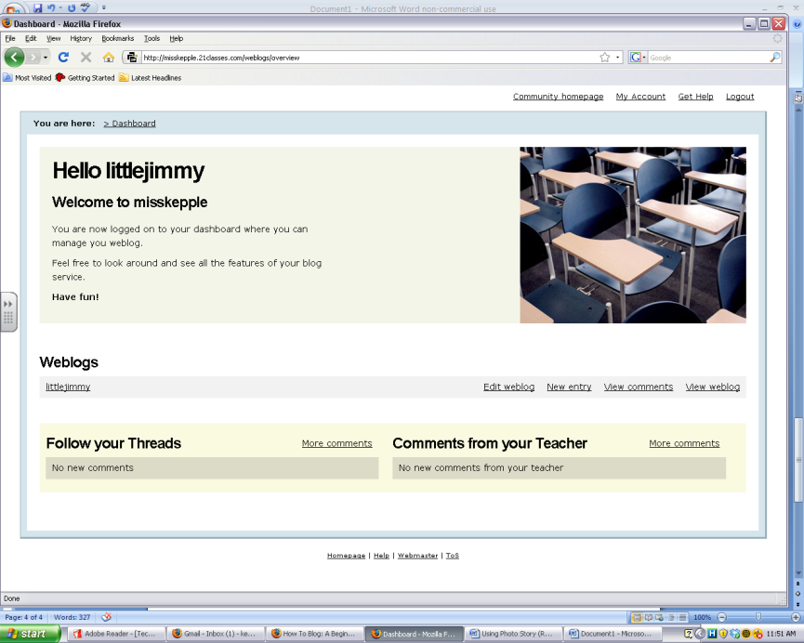

- This is where you are going to write about your reading.
  - For the first entry I want you to write the Title and Author of the book as the header. In the subject, make predictions about what you think your story is about and why it’s interesting to you.
  - The other entries are your choice from the questions in your book packet. Sometimes I may post a question on the community home page so be sure to read it when logging in!

- Create your entry for your reading by typing in the header and the subject line. Next, you need to publish your post or save it to work on later. To publish (you cannot add to it anymore) choose Publish. To come back to this post and make changes, choose Save as Draft.

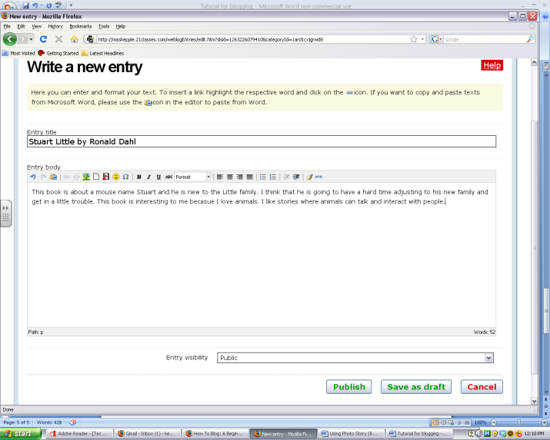

I’m going to work on this later!

All done.

